**Name : Umer yousuf**

**Roll no: 22k-4515**

**Wireshark exercise**

**Q2:**

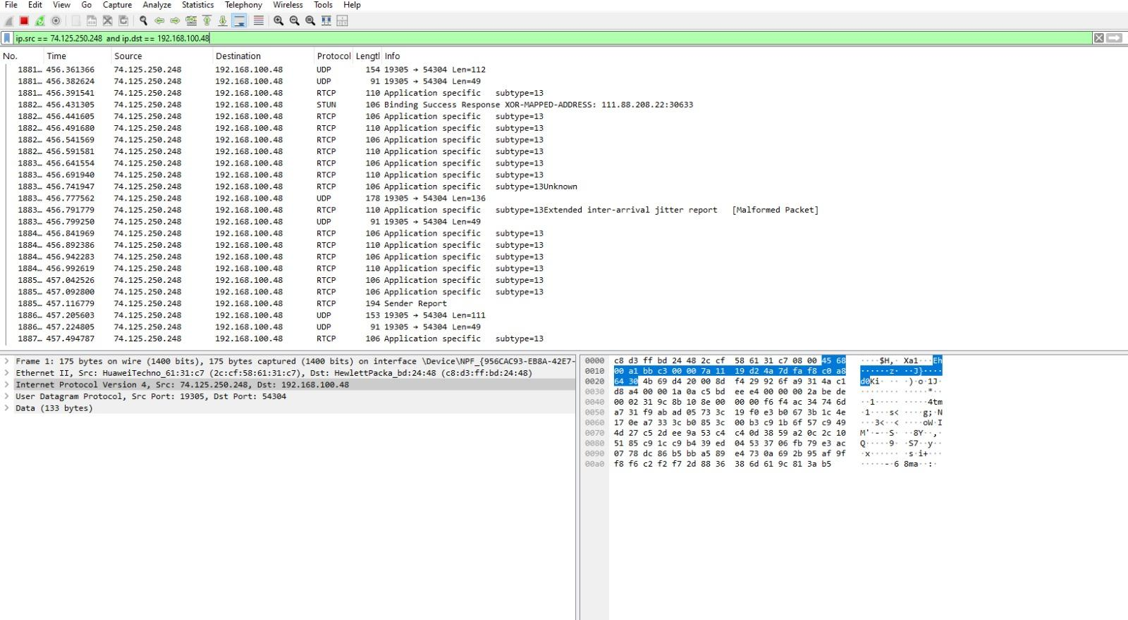

**Q1:**

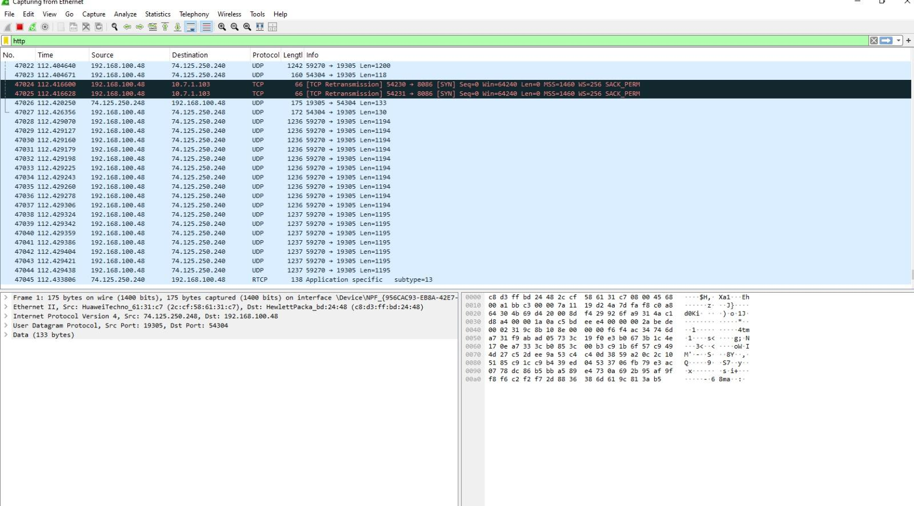

**CISCO packet tracer**

**Q2:**

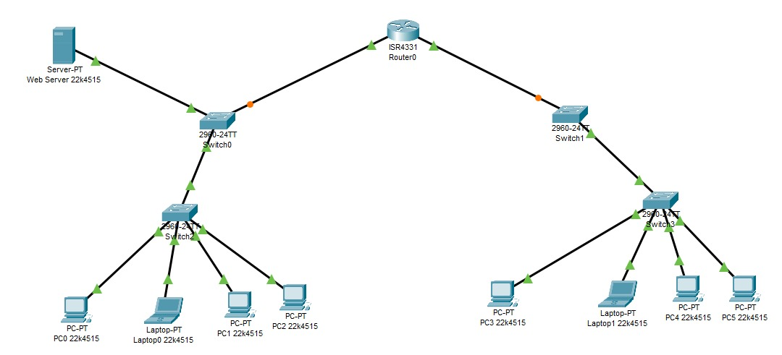

**Q1:**

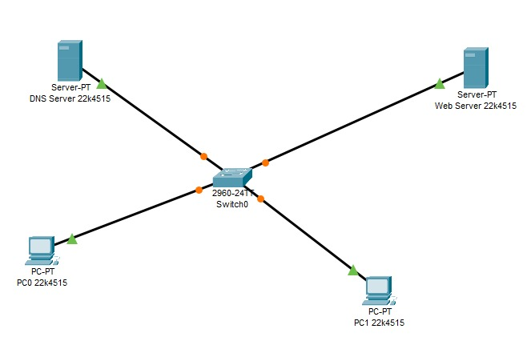

**Q4:**

PUT and POST methods are different; the POST method sends data to the server for processing and is not required to be idempotent, meaning it can leave data and resources on the server in a different state each time it is invoked, while PUT replaces the current resource with the uploaded content

**Q3:**

HTTP response header contains the date and time after which the response is considered expired for HTTP caching[5](https://developer.mozilla.org/en-US/docs/Web/HTTP/Headers/Expires). Expires headers specify a fixed date/time for the expiration of a cached resource, which helps the browser and CDN decide whether to serve a cached version or fetch a fresh one from the origin server[3](https://www.cachefly.com/news/how-to-achieve-web-efficiency-with-expires-headers-and-http-caching/). The format for the Expires header is: Expires: <day-name>, <day> <month> <year> <hour>:<minute>:<second> GMT